R.18
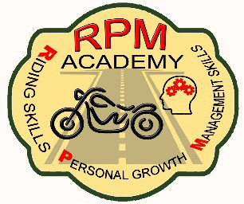

RPM ON BIKE

RPM On Bike Course Announcement & Class Participant Registration Form
Class Organizer(s) ONLY: Provide the following information to RPM RIDER COURSE ANNOUNCEMENT 30 days prior to the proposed RPM On Bike Course to have the class added to the RPM schedule and ensure the participants are served by currently certified RPM Academy Rider Course Instructors. If more than one course is being offered on the same date; complete an announcement form for each course.

Class Date: Start Time: End Time:

Location Address: Contact Name:
Check One :
□ ARC □ TRC □ Trailer

□ Trike & Trailer □ Sidecar
Phone with A/C: ( )

Email:

Additional Information:
cut here

RPM On Bike Participant Registration Form
On-Line Class Registrations w/ Electronic Payments are accepted at: rpm-academy.square.site
Registrants please complete the information below ONLY to register by mail for a scheduled on-bike course.
Date of Submission: Class Date: Your Name: Co-Rider Name:
Check One:
□
□
ARC
□ TRC
Trike & Trailer
□ Trailer
□ Sidecar

Your Address:
Your Phone with A/C: (____) Your Email:
Motorcycle operator must produce valid motorcycle endorsement and proof of current insurance on the day of the course. ALL riders and co-riders must be in full gear on the range including helmet, eye protection, long sleeved jacket or shirt, long pants, over the ankle footwear and full fingered gloves.

Rider Course Registrants: Fee: $45.00 per bike = $____________ □ check □ money order
Do Not Send Cash
Send this completed portion with a check or money order made payable to: RPM ACADEMY
Mail to: RPM Academy c/o Susan Huttman PO Box 2466 Hildebran, NC 28637
……………………………………………….. office use only ……………………………………………….
Check/MO Number: Date received: Date Processed: By:

RPM ACADEMY ON BIKE COURSE ANNOUNCEMENT & CLASS REGISTRATION Apr 2, 2024

